SITEMAP:
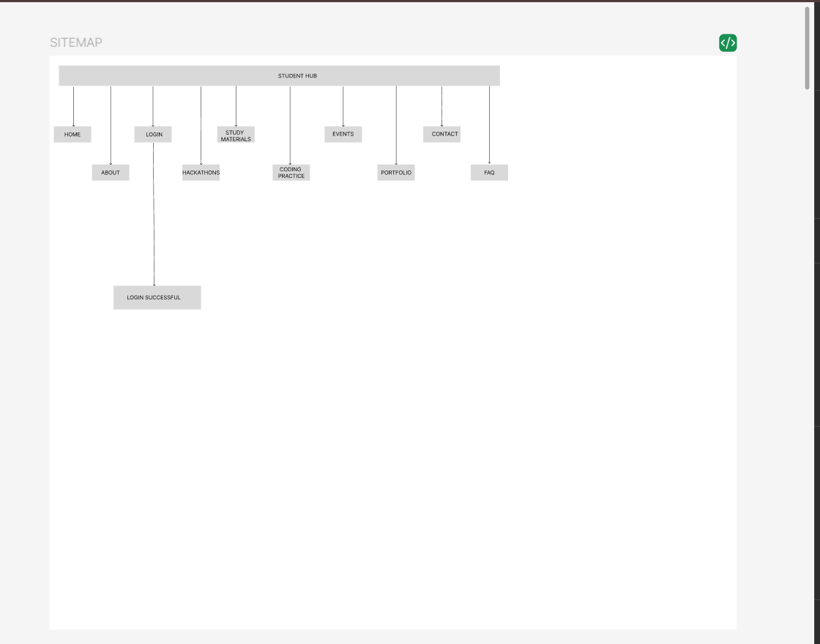

WIREFRAMES: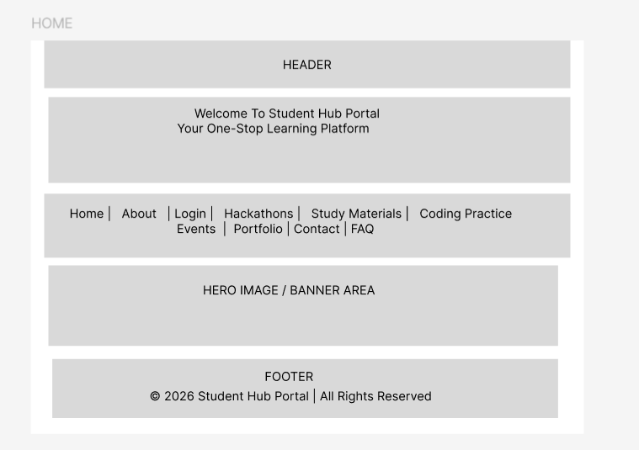
Figure 1HOME PAGE

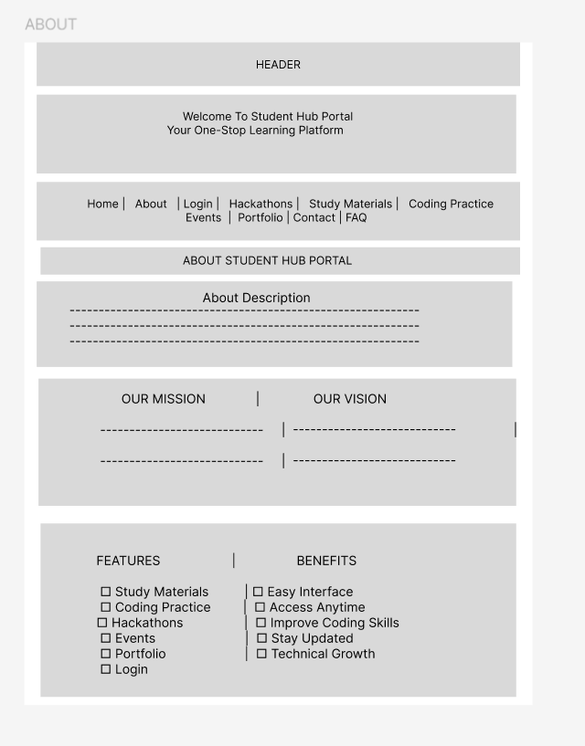
Figure 2ABOUT PAGE
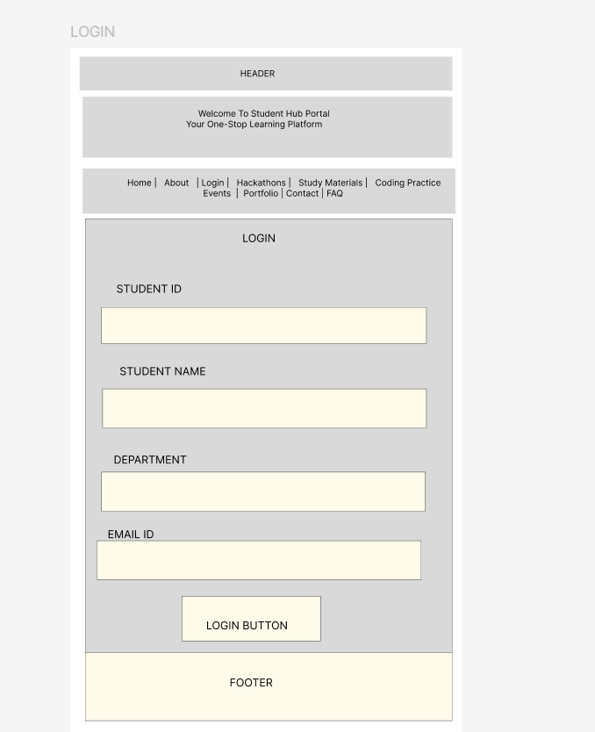
Figure 3LOGIN PAGE

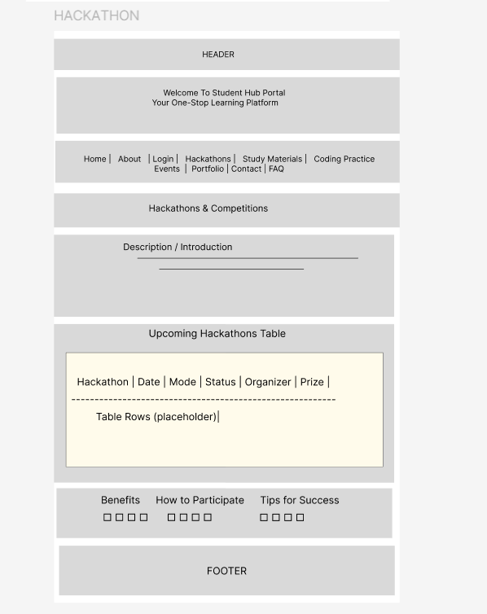
Figure 4HACKATHON PAGE

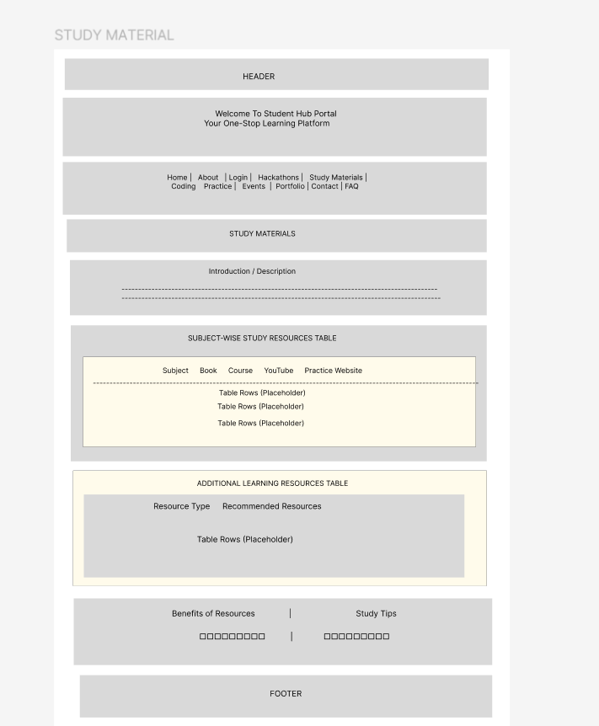
Figure 5STUDY MATERIAL PAGE

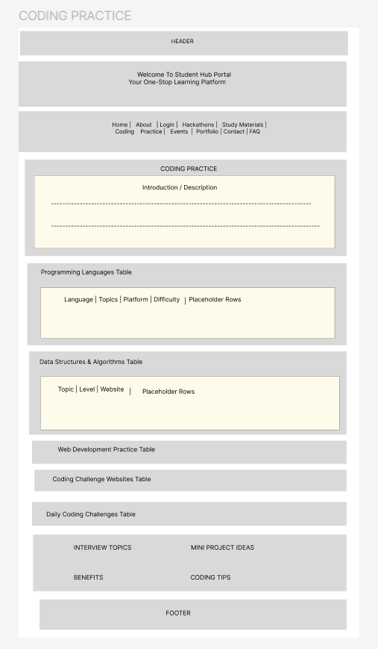
Figure 6 CODING PRACTICE PAGE

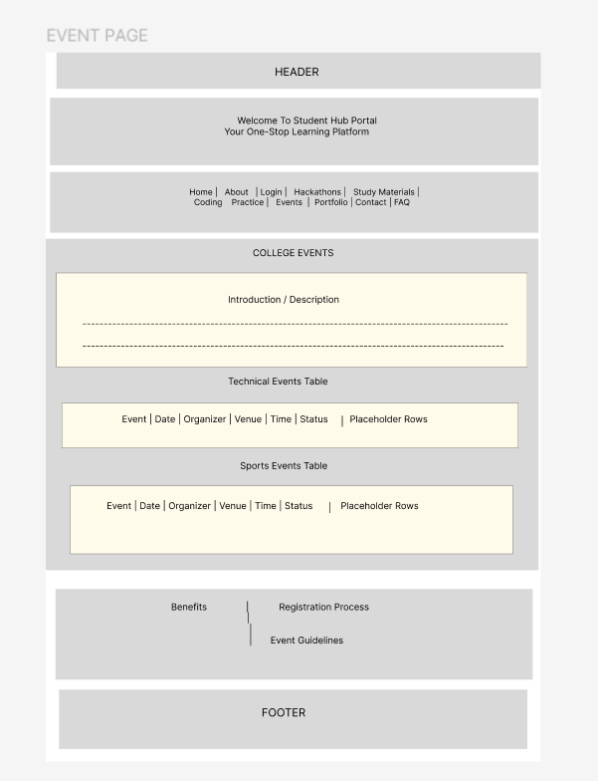
Figure 7 EVENTS PAGE

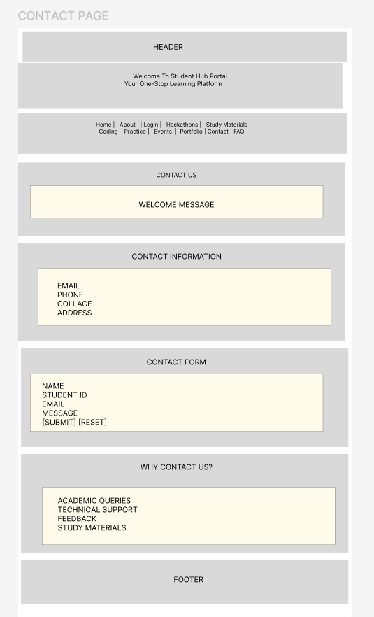
Figure 8 CONTACT PAGE

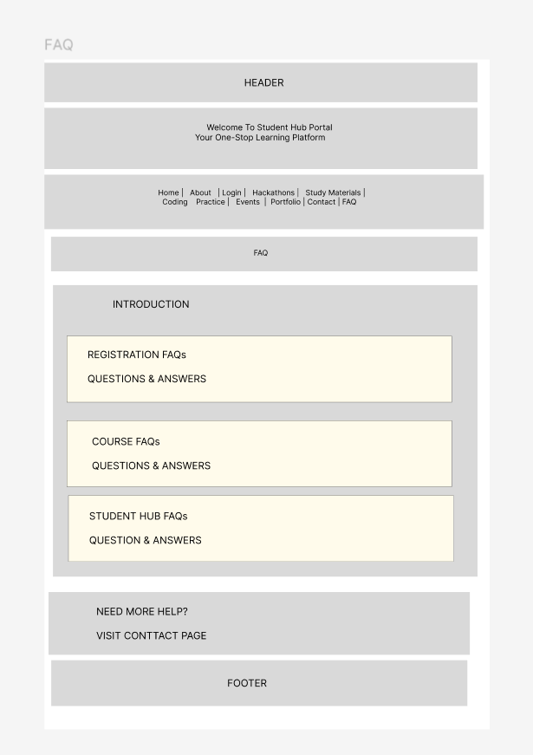
Figure 9 FAQ PAGE

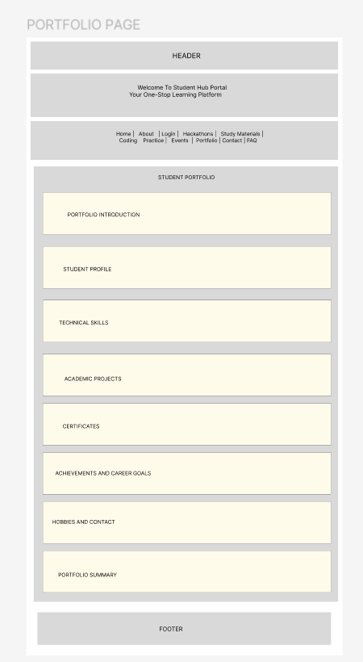
Figure 10 PORTFOLIO PAGESS

